

**UNIVERSITY OF PETROLEUM & ENERGY STUDIES**

**Dehradun**

**APPLICATION CONTAINERISATION**

**Name: Mansi Saini**

**Course: B. TECH CSE DevOps (2018-22)**

**Roll no.: R171218123**

**Sapid: 500071246**

**Experiment No. 14 – Part A**

**Working with Metadata(Labels) in Docker**

**In this experiment, we are going to focus on Metadata, and Labels.**

**Labels can be attached to containers when they are launched via docker run. A container can have multiple labels attached to them at any one time.**

**Follow these steps below:**

**1. For Single Label:**

**To add a single label you use the *l =<value>* option. The example below assigns a label called user with an ID to the container. This would allow us to query for all the containers running related to that particular user.**

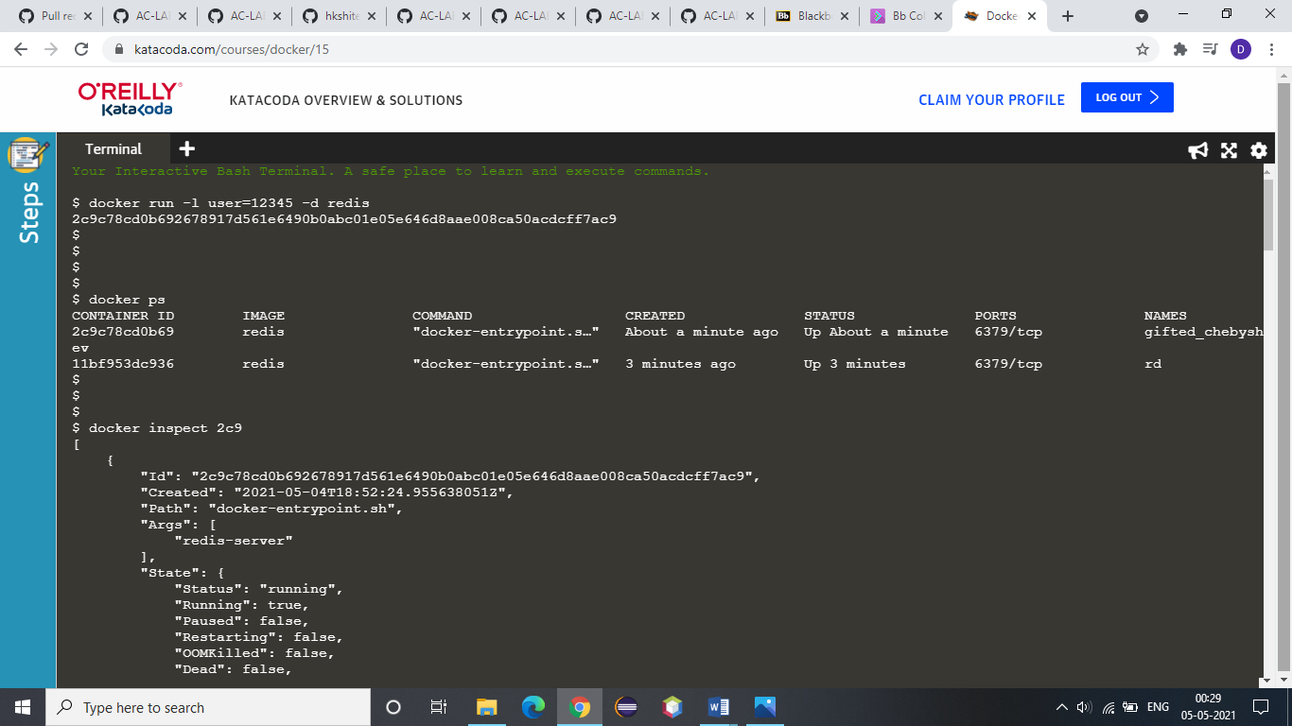

**2. Use dockerps command to check:**



**3. Use Docker Inspect command with the container id to check the label:**



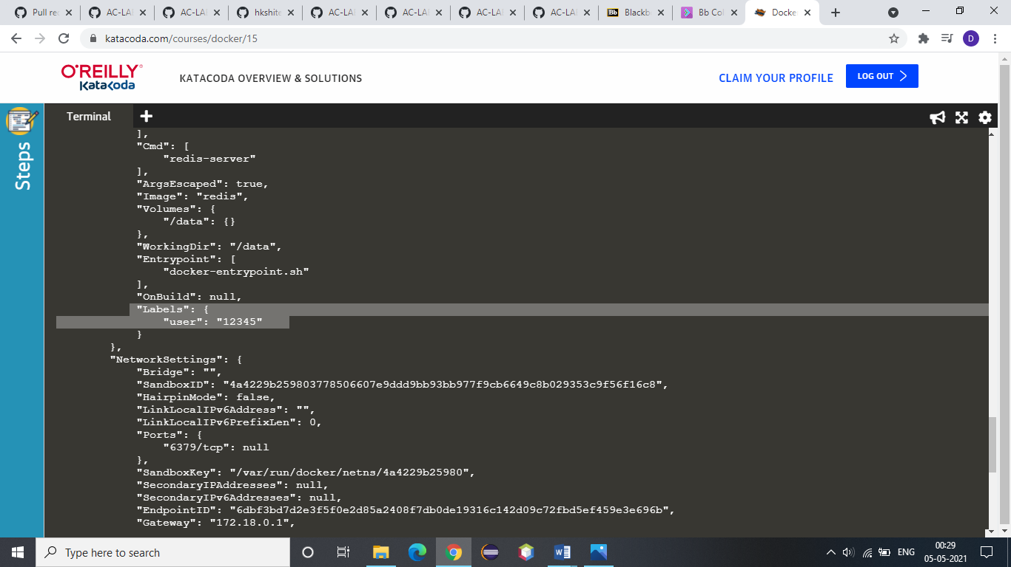

**Now, for multiple labels:**

**If you're adding multiple labels, then these can come from an external file. The file needs to have a label on each line, and then these will be attached to the running container.**

**4. This line creates two labels in the file, one for the user and the second assigning a role.**

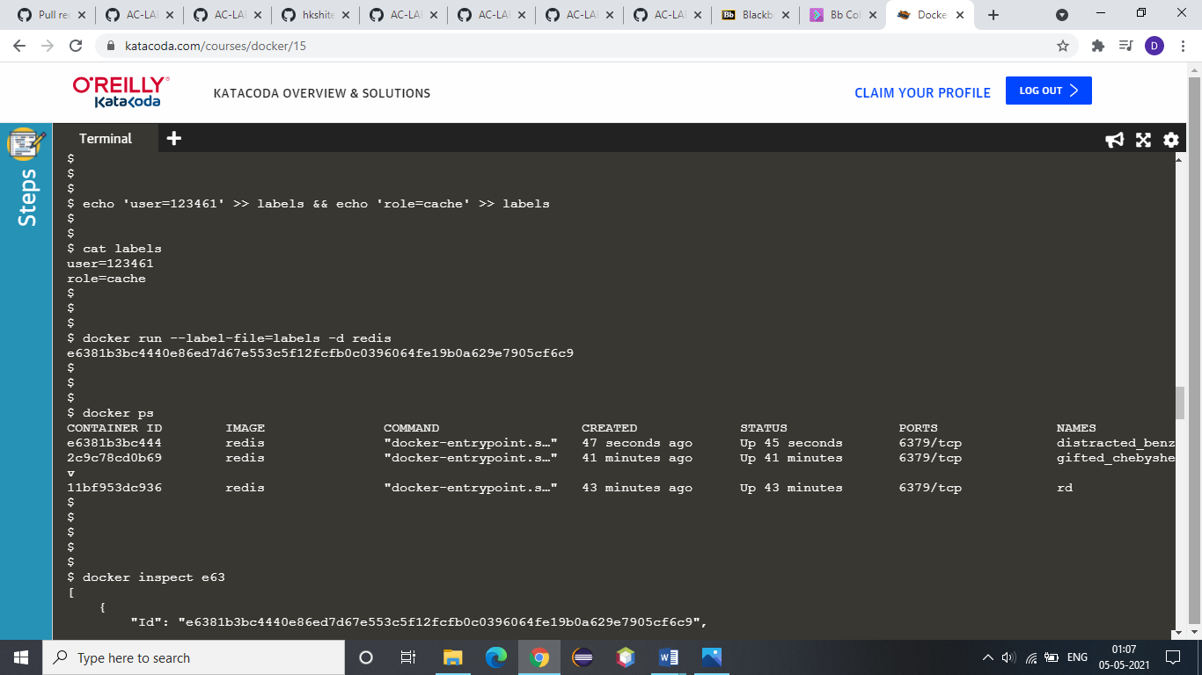

**5. Now run it. The *--label-file=<filename>* option will create a label for each line in the file.**



**6. Now use Docker Inspect <Container Id> to check for multiple labels:**

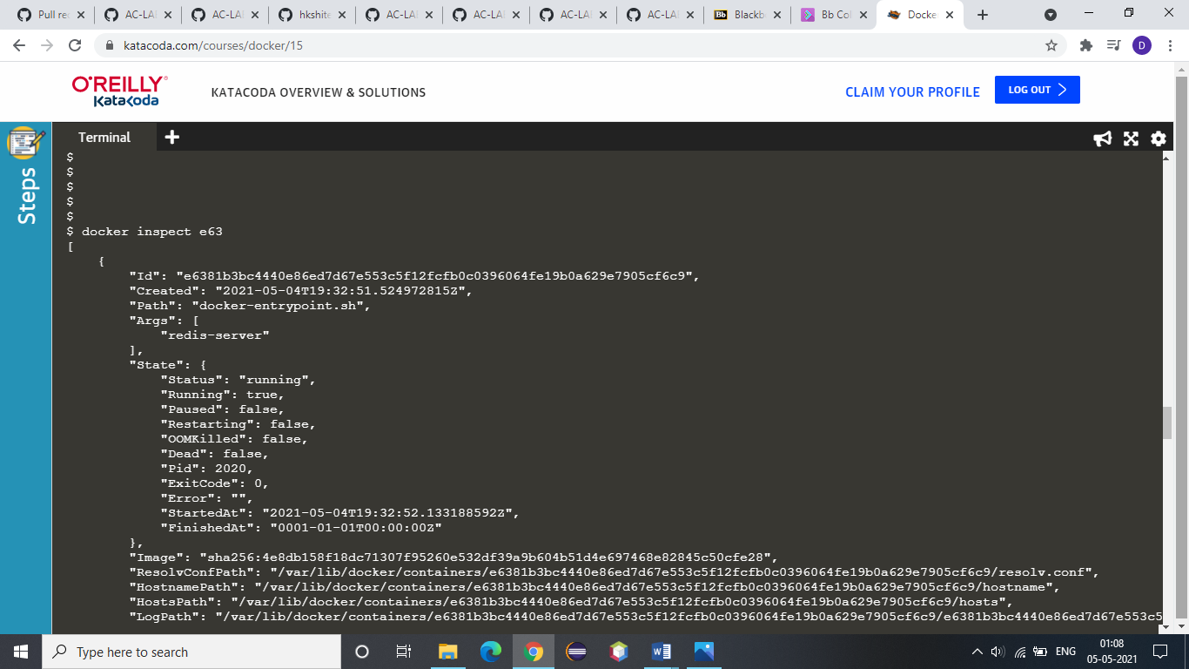

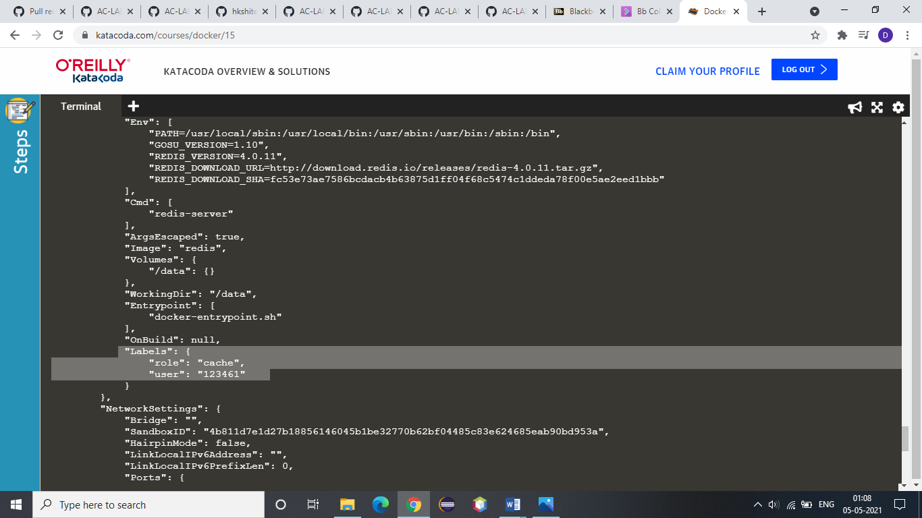

**7. Using the *-f* option you can filter the JSON response to just the Labels section we're interested in.**

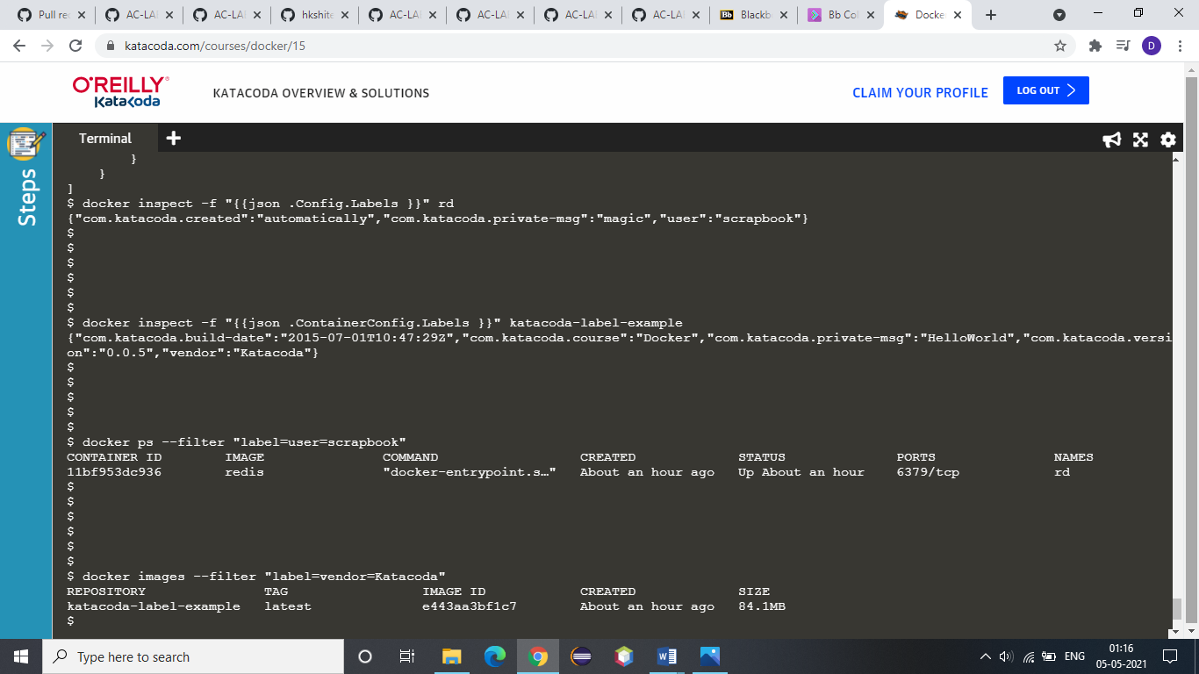

**8. Inspecting images works in the same way however the JSON format is slightly different, naming it *ContainerConfig* instead of *Config*.**



**9. The dockerps command allows you to specify a filter based on a label name and value. For example, the query below will return all the containers which have a *user* label key with the value *katacoda*.**



**10. The same filter approach can be applied to images based on the labels used when the image was built.**



**Experiment No. 14 – Part B**

**Working with Log Files in Docker**

**In this experiment, we are focusing on Log Files in Docker.**

**When you start a container, Docker will track the Standard Out and Standard Error outputs from the process and make them available via the client.**

**Follow these steps below:**

**1. So, there is an instance of Redis running with the name *redis-server*. Using the Docker client, we can access the standard out and standard error outputs using docker logs redis-server**

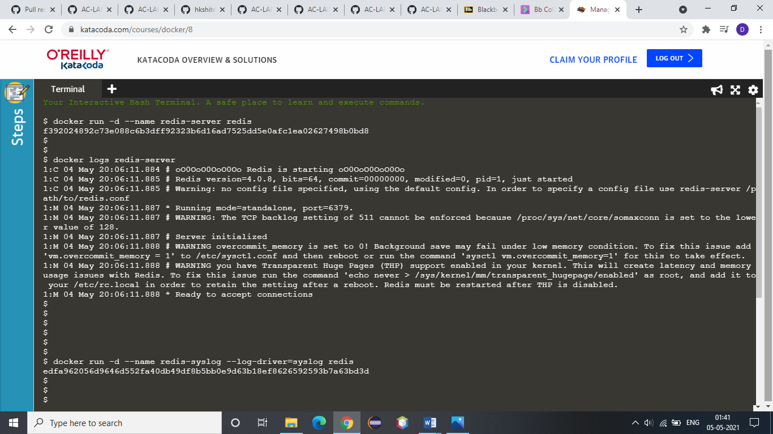

**2. Now, studying the concept of syslog:**

**The Syslog log driver will write all the container logs to the central syslog on the host. The command below will redirect the redis logs to syslog.**



**3. Now, we are focusing on disabling the logging on the container. This is particularly useful for containers which are very verbose in their logging.**



**4. The *inspect* command allows you to identify the logging configuration for a particular container. The command below will output the LogConfig section for each of the containers.**

**a) Server created in step 1:**

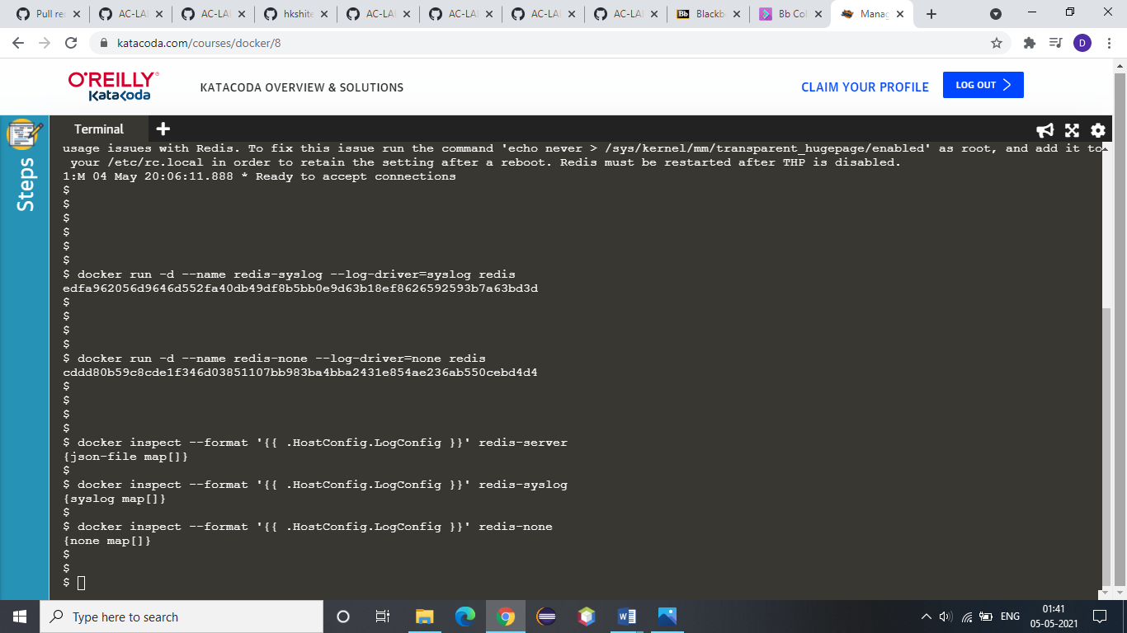

**b) Server created in step 2:**



**c) Server created in Step 3:**

